SW Camera application software operation manual

1. Software function introduction
This is specialized application measure software in order to expand the function of our camera.
The software includes three functions: Video Process function, Image Process function, Image Measure function. Figure 1 is the main window of this software.

Figure 1.The main window
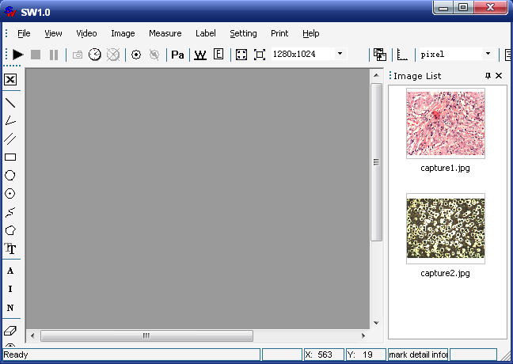

The Video Process function is used to process the video stream acquired by camera. The main functions are:
- The video real time play, pause, stop function.
- Auto white balance and auto exposure function.
- Video collect functions, includes static image capture, dynamic image record, timing auto capture, actual image collection.
- Video parameters setting function (RGB setting, gamma correction, exposure setting, offsets setting etc.)
- Control the video shown at different scales and control the size of the video display area Functions.
- Video up/down, left/right overturned function.
- Real time dynamic algorithm for video clearly.
- Video conversion between color and black-and-white;
In order to enhance the images and get some special effects, we need Image Process function to process the captured images. The main functions are:
- Soften and sharpen image. The softening is used for eliminate noise, smooth image. The sharpening is used to prominent edge; enhance the visual effect of the image.
- Light and contrast adjustment.
- RGB gain adjustment.
- Several pictures combination function. It include and, or, superposition and so on up to 10 operations for several pictures combination.
- Mirror and rotate function.
- Get edge function.
- Emboss effect.
The Image Measure function is mainly used in video microscope. In response to the pictures collected under different magnifications, this software gives the different setting standard respectively. The actual size of the related graphics acquired only by choosing the corresponding standard. This software can measure the following types of the graphics:
- Measure the length of the straight line and curve.
- Measure the edge length, area and perimeter of the rectangle.
- Measure the radius, area and perimeter of the circular.
- Measure the area and perimeter of the arbitrary polygons.
- Measure the angle.
- Measure the distance between the parallel lines.
- Text input function.
- Counter function.
- Measurement fine-tuning function.
- Delete graphic element function.
- Mark choosing function.

2 Detailed using instruction
Notice: The software must link of our company’s camera.

2.1 Video process function instruction:
The Main control function of this part can complete by using the above toolbar of the main window. As figure 2.1 shows:
Figure 2.1 Toolbar Function
These three buttons are used for video Play, Stop and Pause
This group is capture function button. (Capture a frame)This button is used to capture the usual video. These two buttons (clock form) can realize timing capture function. Click on (set interval) button on the toolbar, timing capture dialog will pop up. (As figure 2.2 shows)
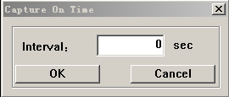
Figure 2.2
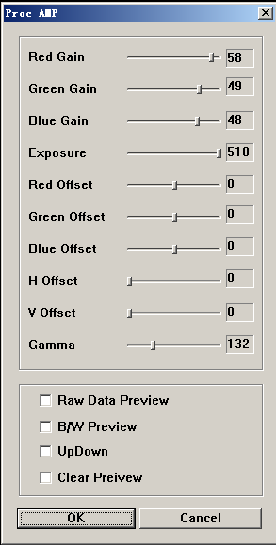
Figure 2.3 We can set time interval for image capture in this dialog, the parameters can be set as decimal fraction, which unit is sec (at least 0.5 sec). This part of function is effective when the video is opening.
Click on (stop capture) button on the toolbar, will stop capture.
Starts to record AVI stream, currently achieve no compressed video functions. is used to stops recording.

Click on (proc amp) button, video parameter setting dialog will pop up, in which we can adjust RGB gain, RGB offset, Exposure, Gamma and image display Offset. The Image Display Offset is divided into Vertical offset and Horizontal offset. Horizontal offset is a migration of the image on horizontal direction. Vertical offset is a migration of the image on vertical direction. This dialog also has black and white color conversion (B/W preview), primitive data putout (Raw data preview), up/down overturned (Up down) and video sharpen (Clear preview) function etc. These functions are effective when the video is opening. (As figure 2.3 shows)
The next two buttons are used to implement Auto White Balance (AWB) and Auto Exposure (AE) function for video stream respectively.
These two buttons realize zoom in and zoom out for video display,
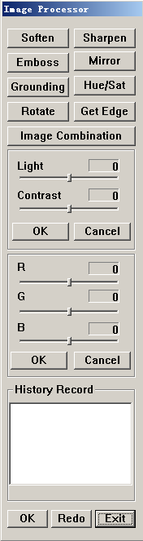
In order to get the image which out of the user area, we can Click the (Zoom Video to Window) button, the whole scene zoom out and displays all in the user area Conversely, click on (Actual size) button, the image will display in its actual size，to view the image which out of the user area we can drag the scroll to get them. This function is effective when the video is opening.
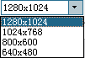This box is used to set resolution. Resolution is used to set the width and height for the video stream. For the type of Zoom camera, the software provides four resolutions (2048x1536, 1280x1024, 800x600, 640x480) to choose. While For the Cutting camera, it can set free resolution base on the user needs.

2.1 Image process function
This function requests to stop the video stream and load in a static picture from the customer district of the main window. Load a picture is very simple, just click on the picture which you want from the Image List on the right of the main window.
As the video process, the image process part also has zoom in and zoom out functions .This function can realized by clicking on the buttons on the toolbar. “Zoom image to window” button show picture as window size.
Figure 2.4
This button can show the picture as the actual size.
Notice: if the primitive picture size is smaller than the size of window customer district, this buttons is ineffective. In addition when you mark the image these buttons are all show like this , and it can return to the state only by right click.
On the main toolbar, these two buttons realize the saving and deleting function. (Notice: if open a static image, make the size and number marker, click on “save” button at this time, then we will get a new picture include all the marker information. So the original picture can save.) This button realize save as function, can give definition of the save path free. (Notice: if we first make marker on the original picture, then click on “save as”, the picture can save as designated trail, but the image view menu will not show this picture.) This button is used to delete the picture already load in. The software will auto load in another picture after delete.
In order to process picture conveniently, this software designs the image process dialog specially for processing picture conveniently (As figure 2.4 shows). After load in the picture, you can choose “Image→ImagePro” from the main menu to open image processor, and also can click on (image processor) button on the toolbar to open the image processor. The image processor includes: soften, sharpen, emboss, mirror, grounding, hue/ saturation, rotate, combination, get edge, light/contrast, RGB adjust, history record, ok, redo, exit function etc.
In addition, here also set up the light/contrast and RGB adjust function on the image processor. Beneath these two functions is the corresponding “OK” button, we suggest to click on this button after operation, otherwise the information that just operated maybe lost when doing another operation.
We set up the “redo” button to process the wrong operation or the current effect which we are not contented. After click on the “redo” button, the picture will resume the effect as the last click on OK. If not clicked on “OK”, it will resume the primitive picture.
Click on “exit” button, can exit the image processor dialog.
There is a history record box under the image processor; it is used to record the every step of the process operation.
There is a combination button on the image processor, click on it, will pop up another dialog (As figure 2-5 shows), it can realize two or more pictures combination function on this new dialog. This dialog provides more than ten different combination methods. We can decide the combination position of the two pictures through adjusting the offset.
After opening the image combination panel, first click on “load in the source picture” button, the picture on the main window can be load in this panel (As figure 2-5 shows). Of course, you can choose another picture first. The load picture method is click on the image thumbnail which you wanted from the image list on the right of the main window first, and then click on “load in the source picture” button. After then, choose the second picture, click on the “load in the object picture” button, then load picture is completed. If not choose the second picture, it will load in two same pictures.
There are ten different combination methods on the left of the image combination dialog, we can do these operations after load in the pictures. The result can display on the left of the panel.
To combine more pictures, go through the under steps:
  - First load in two pictures, to complete the combination of the two pictures.
  - Click on load in the object picture button, save the current operation result as a new picture.
  - Choose a new picture, click on load in the source picture to complete the third picture load in.
  - Then do the combination operation, complete the three pictures combination function. Repeat in this way, can complete the more pictures combination.
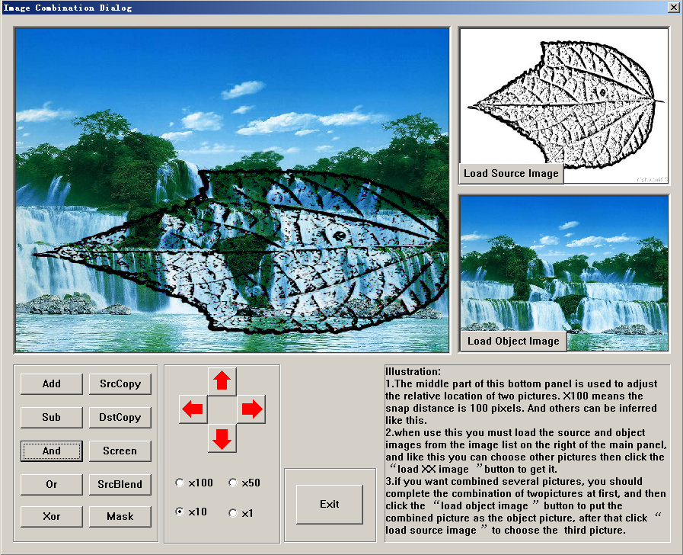
Figure 2.5 Image combination dialog
The four red buttons in the lower part of the dialog are used to adjust the relative position of the combination pictures. The four individual choice buttons on the beneath stand for snap distance of every adjust operation, “100x” stands for removing 100 pixels every time, followed by analogy.
After exiting this dialog, we can see the display picture is replaced by the current effective picture, and we can do other operation then. We suggest clicking on the “OK” button in the lower part of the image process dialog before do other operations, otherwise the completed combination effect will disappear when implement the “redo” function.

2.2 image measure function
This is the main function which is designed for the video microscope, can acquire the actual size of the captured objects according to the different microscope magnification.

2.2.1 Image standard setting & yardstick choosing

When first using this software, we need set standard for the different object lens, this point will discuss later.
This group buttons on the main toolbar is used to set standard and choose yardstick. To facilitate the different user groups, this software provides the following two choices for yardstick choosing. (Notice: it can be used after setting standard)
1. The drop-down list box provided in the common use of the microscope object lens magnification. As figure 2.6 shows:
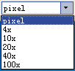
Figure 2.6
Thereinto, choosing the “pixel” then the value we get stands for the number of the pixel in the measure range, “4x” means the object lens multiplier is four times. When customers use it, for pictures captured by different object lens, just choose corresponding object lens magnification. The unit is micron. When first using this software to measure, don’t choose the object lens magnification in the drop-down list to measure immediate, you should set standard on the corresponding object lens magnification first, and then measure.
2. Image setting standard button is used to choose user-defined multiples setting standard function. Click on it will pop up the under dialog:
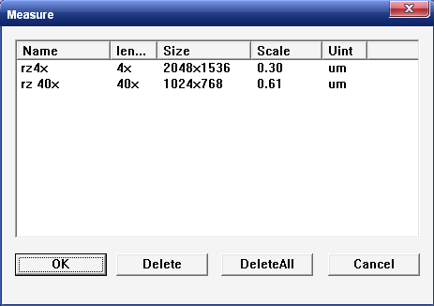
Figure 2.7
As figure 2.7 shows, this dialog has a detailed yardstick name, the adapted size of the picture, the magnification and the related unit. When using, first selected the project needed, and then click on “OK”.
Now let’s discuss in detail about the most important function of the Picture Setting Standard. Setting standard is the core of this software, the measure is the empty talk without this function. But it doesn’t mean that the setting standard method is very complex. It is easy to complete the setting standard if you follow the next steps.
- First, you must have a Standard Micrometer Scale, capture a picture of the micrometer scale in the microscope, and must record the object lens which you used.
- Load in the picture, click on the setting standard button on the toolbar. Pull a straight line between the two setting standard points, as figure 2.8 shows. Read the actual size according to the calibrations of the micrometer scale in the picture. Every little grid is ten microns in the picture. The distance between the two setting standard points is 200 microns. This picture is captured in the 10x object lens.

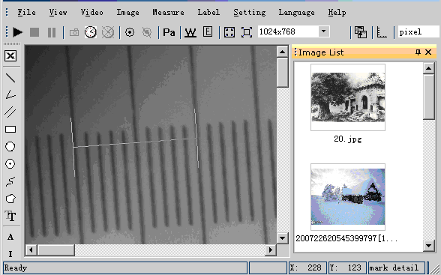
Figure 2.8

- The mouse left-click can pop up a dialog, as figure 2.9. It can auto give the picture size and the pixel distance between the two setting standard points (The unit of the distance between the two points is pixel). The top two boxes are independent of each other in the picture; as a result there is only one box effective at the same time. These two boxes respectively corresponding to the above-mentioned two select yardstick way.
Among them, scale corresponding to the on the toolbar. As figure 2.10 shows, the drop-down list box after the “scale” has the same object lens magnification choice as the . We can select the corresponding object lens magnification in this. In response the picture in the figure 2.8, you need select “10x” project. Then input the actual size measured in the “Actual Size”. Click on “OK” can complete the Yardstick setting standard work in the 10x object lens and 1280*768 resolution situations. For the same conditions when the picture measure, it is only to select “10x” in the to measure then.

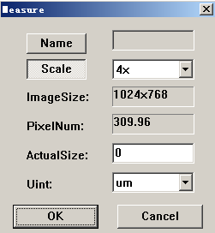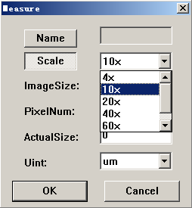
Figure 2.9 Figure2.10

The “Name” is corresponding to button, click on “Name”, input the object lens name you wanted in the editor frame behind, as figure 2.11. The same, system offers the picture size and pixel distance for you. Then input the actual size. You can set the unit here. As figure 2.12, the system offers three units for choice(The default unit is micron). The Setting Standard function complete when clicking on “OK” button.

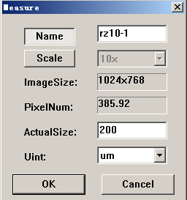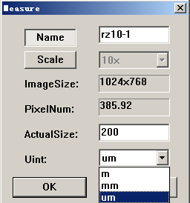
Figure 2.11 Figure 2.12

Now click on the image setting standard list button, pop up figure 2.13 dialog. Comparison with figure 2.7, there is a new option that we just set.
Figure 2.13
2.2.2 Image measure function
This part function can achieved by calling the relate buttons of the toolbar on the left. As figure 2.14 shows:
Figure 2.14
“(Combination and Save)”button is used for all the measure data information export to the Excel table. All the relevant information of one picture will be saved in a Excel table, other exportions will be saved in the same table.
Notice: before use the Excel table, don’t click on the “save” button. All the pictures and Excel tables are saved in the Pic file.
The several followed are Line measure, Angle measure, Parallel Distance measure, Rectangle Area、Perimeter measure, Three points circle, Center circle area、 Perimeter、Radius measure, Curve Perimeter measure, Polygon Perimeter、Area measure, Text labeling, Setting marker types, Delete, Fine-tuning and Mark functions.
The following is a brief explication for the measure operation; take the example of polygon measure.
“The Arbitrary Polygons” and “Curve” are composed of many lines essentially. When start drawing, we need to use the left-click to input many points to complete drawing. The maximum input is 200 points once. Click on the same position two times continuously (Notice, not double-click fast) can complete the drawing. Arbitrary polygon can automatically connect the end and start point to get the closed graph. “Right-click” cancels the operation when drawing. Then can re-select the start point. If not in drawing, right-click exits the draw operation.
The system can give the relevant measure argument automatically after complete the drawing.
Another point we should explain is that the line and the rectangle are completed by left-click twice, but not click on one point then pull to complete.
Notice: For each graphic element, the memory will distribute corresponding space to store.
is used to set the marker types. Setting these three buttons to give the customers different choices, it is because that not all the customs want to put all the information on the picture. “” is the first letter of “all”, means mark all the generation information on the picture. “” stands for “Index”, means only marking the index of the graph. “” stands for “nothing”, means doing no marker for graph. When using them just click on the relevant icon, related tips will be given beneath the status bar of the software interface.
“(Earse)” is used to delete the graphic element drawn. Click on the icon first, and then select the graphic element by the mouse arrow cusp, the selected graphic element will become the red point line at this time, left-click to delete the graphic element. “” is Fine-tuning button. Generally, it is not accurate to use the mouse to set the measurement point. Add this function can use the keyboard to accurate set the position of the measurement point. The method is first click on this button, then click on the graphic element you wanted, the selected graphic element will become the red point line, simultaneously a marked point comes out. At this time, “A” “S”“D”“W” keys are used to adjust the position of the mark point. E”and“Q” are used to switch the position of the mark point. Click on spaces key can complete and exit.
“” This grope buttons achieves the counting function.
After click on “”, will pop up a dialog, as figure 2.15 shows. It is used to set the counter types, name, size, color and index. When making the counting marker, it will show corresponding number in the marker. Input the value in the “index” box to change the number of the marker. The input value must be a positive integer.
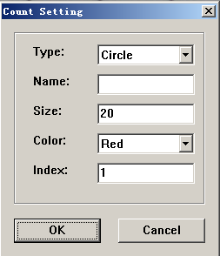
Figure 2.15
“” is representatives for three different Shapes of Icon which this software only has. Counting marker can also use “(Erase)” to delete.
2.2.3 Image print function
The icon “ ” is represent for print function. Please choose scale before you print image. To choose the scale. Click the icon, then a setting box will be pop up, as shown in picture 2.16:

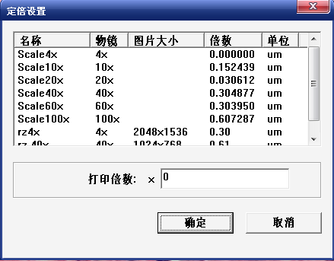
Please choose an item from “Name” list, (such as “scale 10X”), then typing an exact multiple in “customize print scale”. The value you filled in is represent for the multiple of the actual size of the object. Click “ok” to end up setting scale. Then you can print the image by click the “”

Finally, we emphasize that doing the image measurement should in the original size, otherwise the parameters cannot be right.

